Practice 2
Student name: Adilkhan Igisinov
Student ID: 25B030857
Group: Tue 13
What is the Dst Port value for Layer 4 under the Out Layers column? Destination Port is 80
What is the Dest. IP value for Layer 3 under the Out Layers column? It is the IP address of the Web Server.
What information is displayed at Layer 2 under the Out Layers column? The Source and Destination MAC addresses.
What is the common information listed under the IP section of PDU Details as compared to the information listed under the OSI Model tab? With which layer is it associated The Source and Destination IP addresses. It is associated with Layer 3 (Network Layer).
What is the common information listed under the TCP section of PDU Details... and with which layer is it associated? The Source and Destination Ports. It is associated with Layer 4 Transport Layer
What is the Host listed under the HTTP section of the PDU Details? What layer would this information be associated with? The Host is www.osi.local This is associated with Layer 7 App Layer
Comparing the information displayed in the In Layers column with that of the Out Layers column, what are the major differences? The major difference is that the Source and Destination IP addresses and MAC addresses swap places, because the receiving device is now becoming the sending device to return the message.
What additional Event Types are displayed? Additional event types displayed include DNS, ARP, and TCP.
What information is listed in the NAME field in the DNS QUERY section?
www.osi.local
At which device was the PDU captured? Web Client
What port number is the Web Server listening on for the web request? The Web Server is listening on port 80.
What port is the Web Server listening on for a DNS request? The Web Server is listening on port 53
- 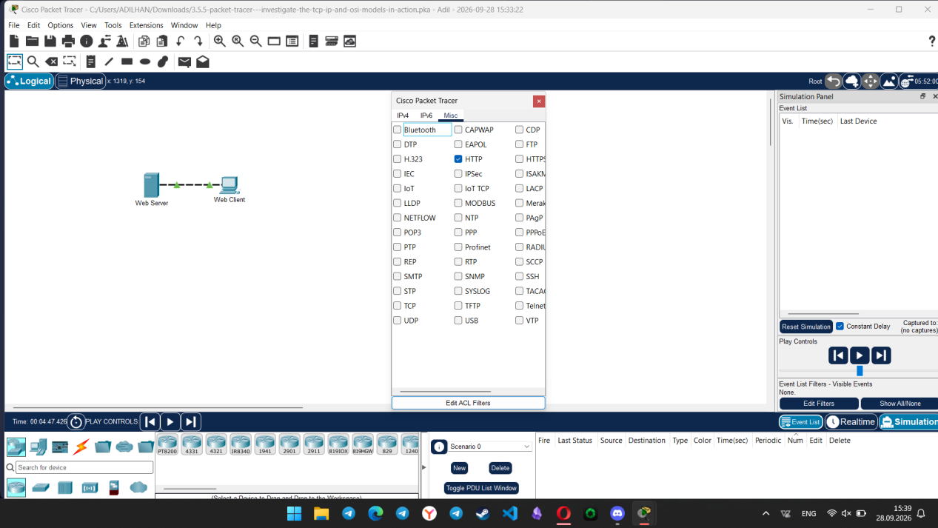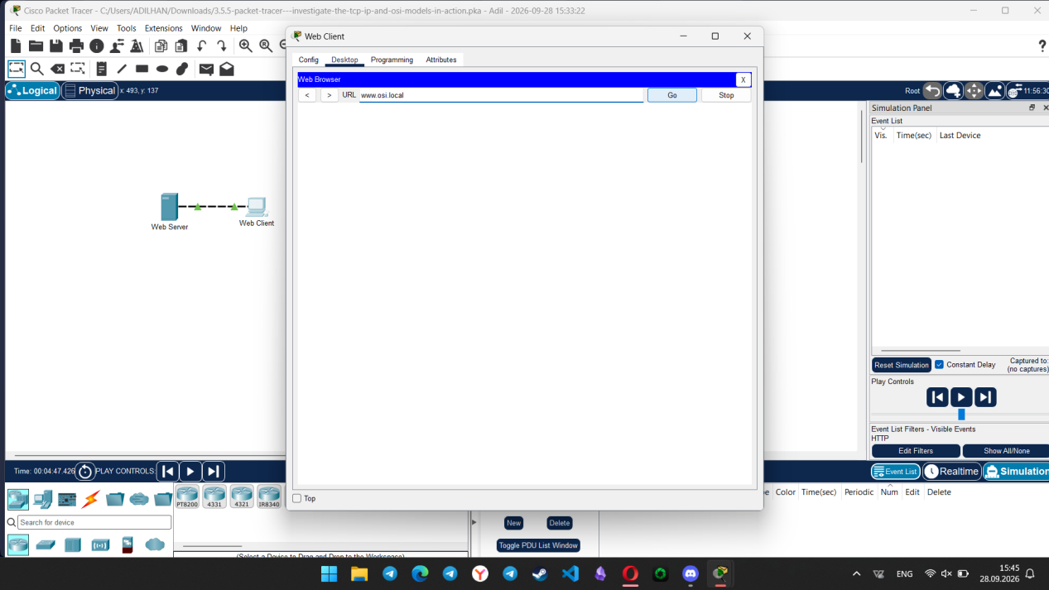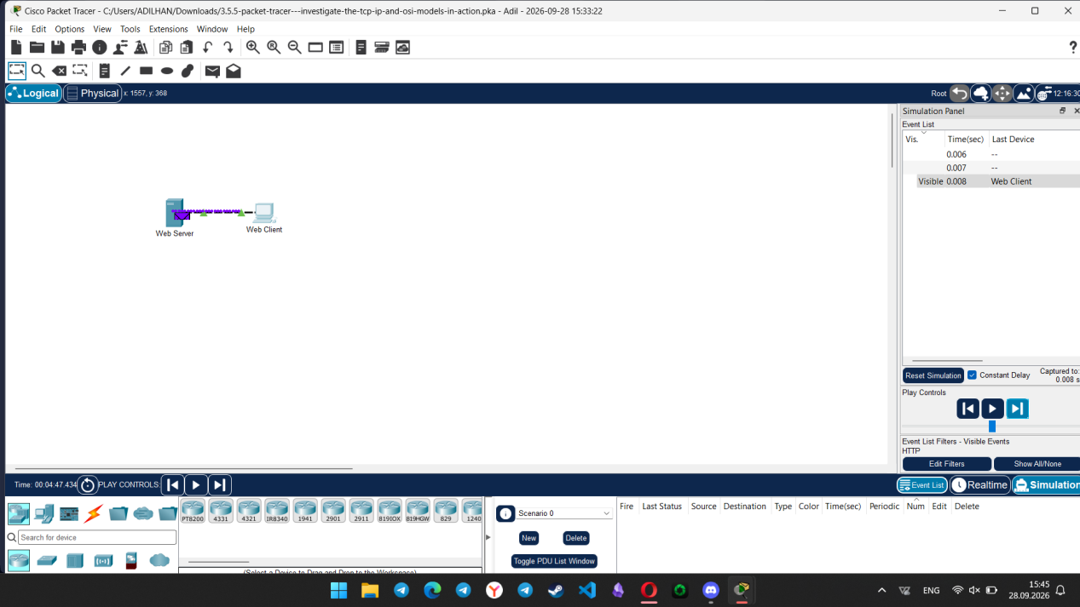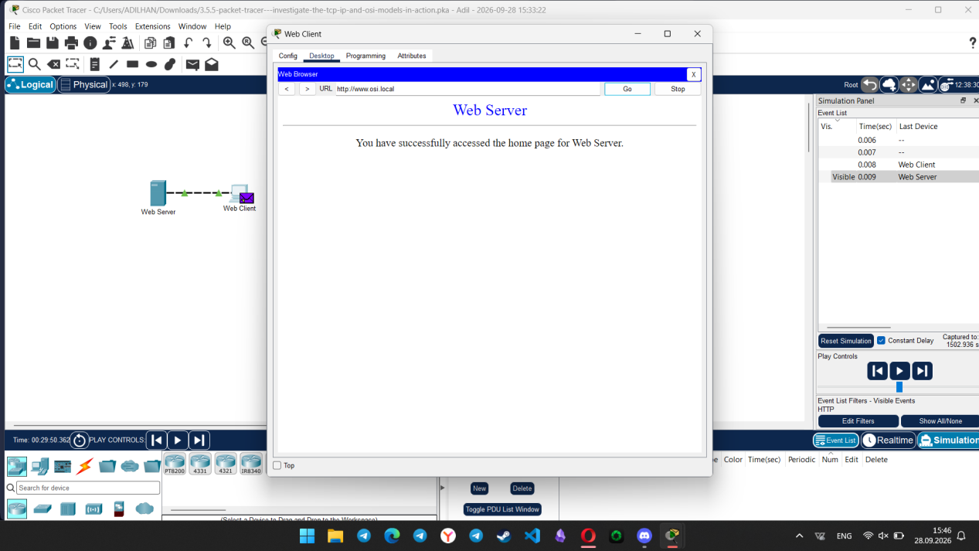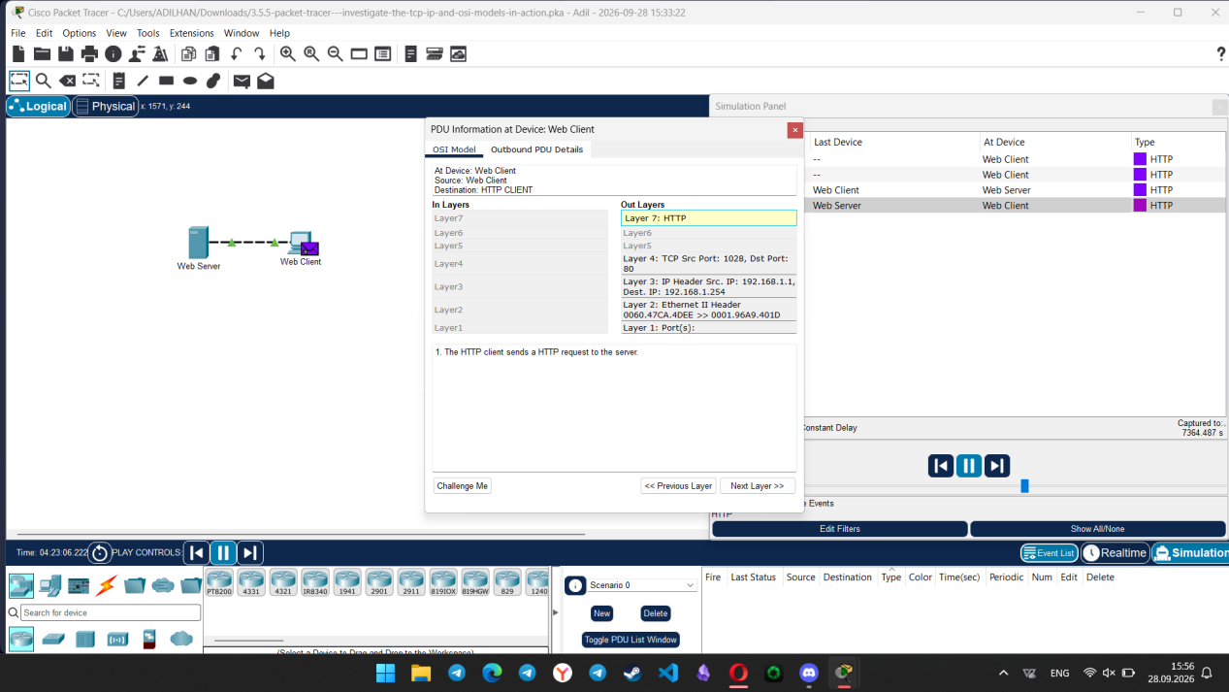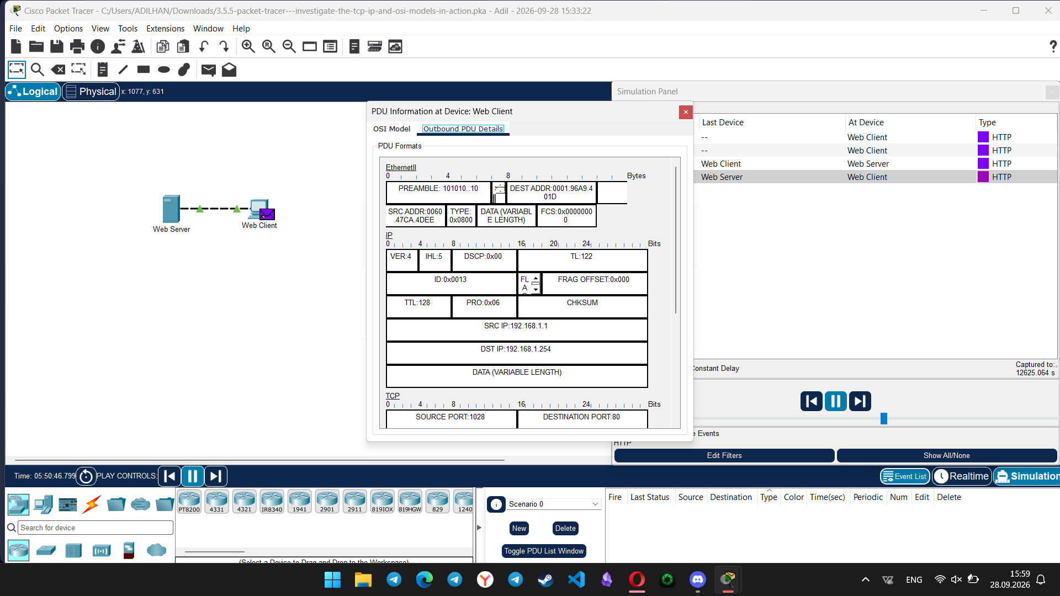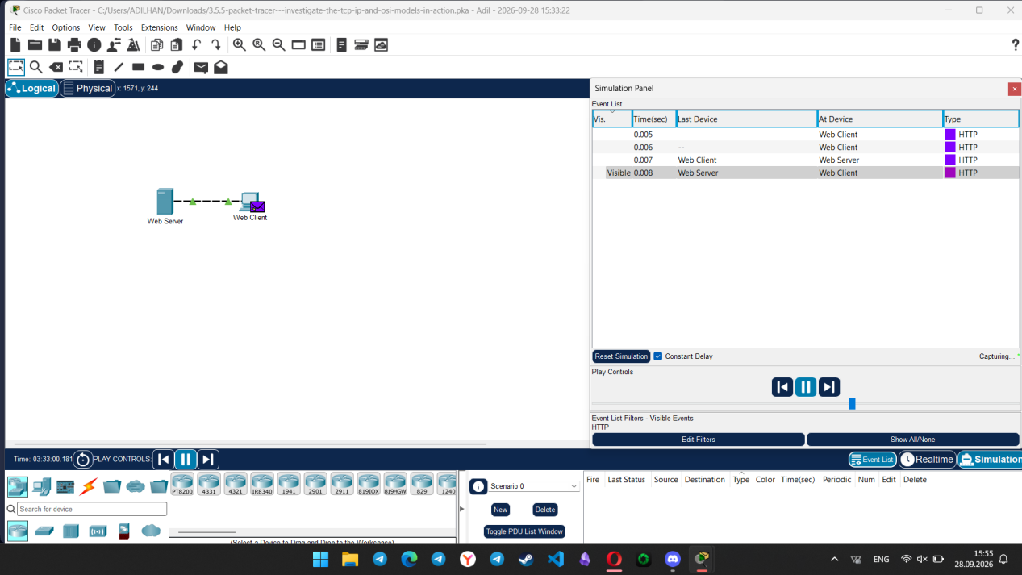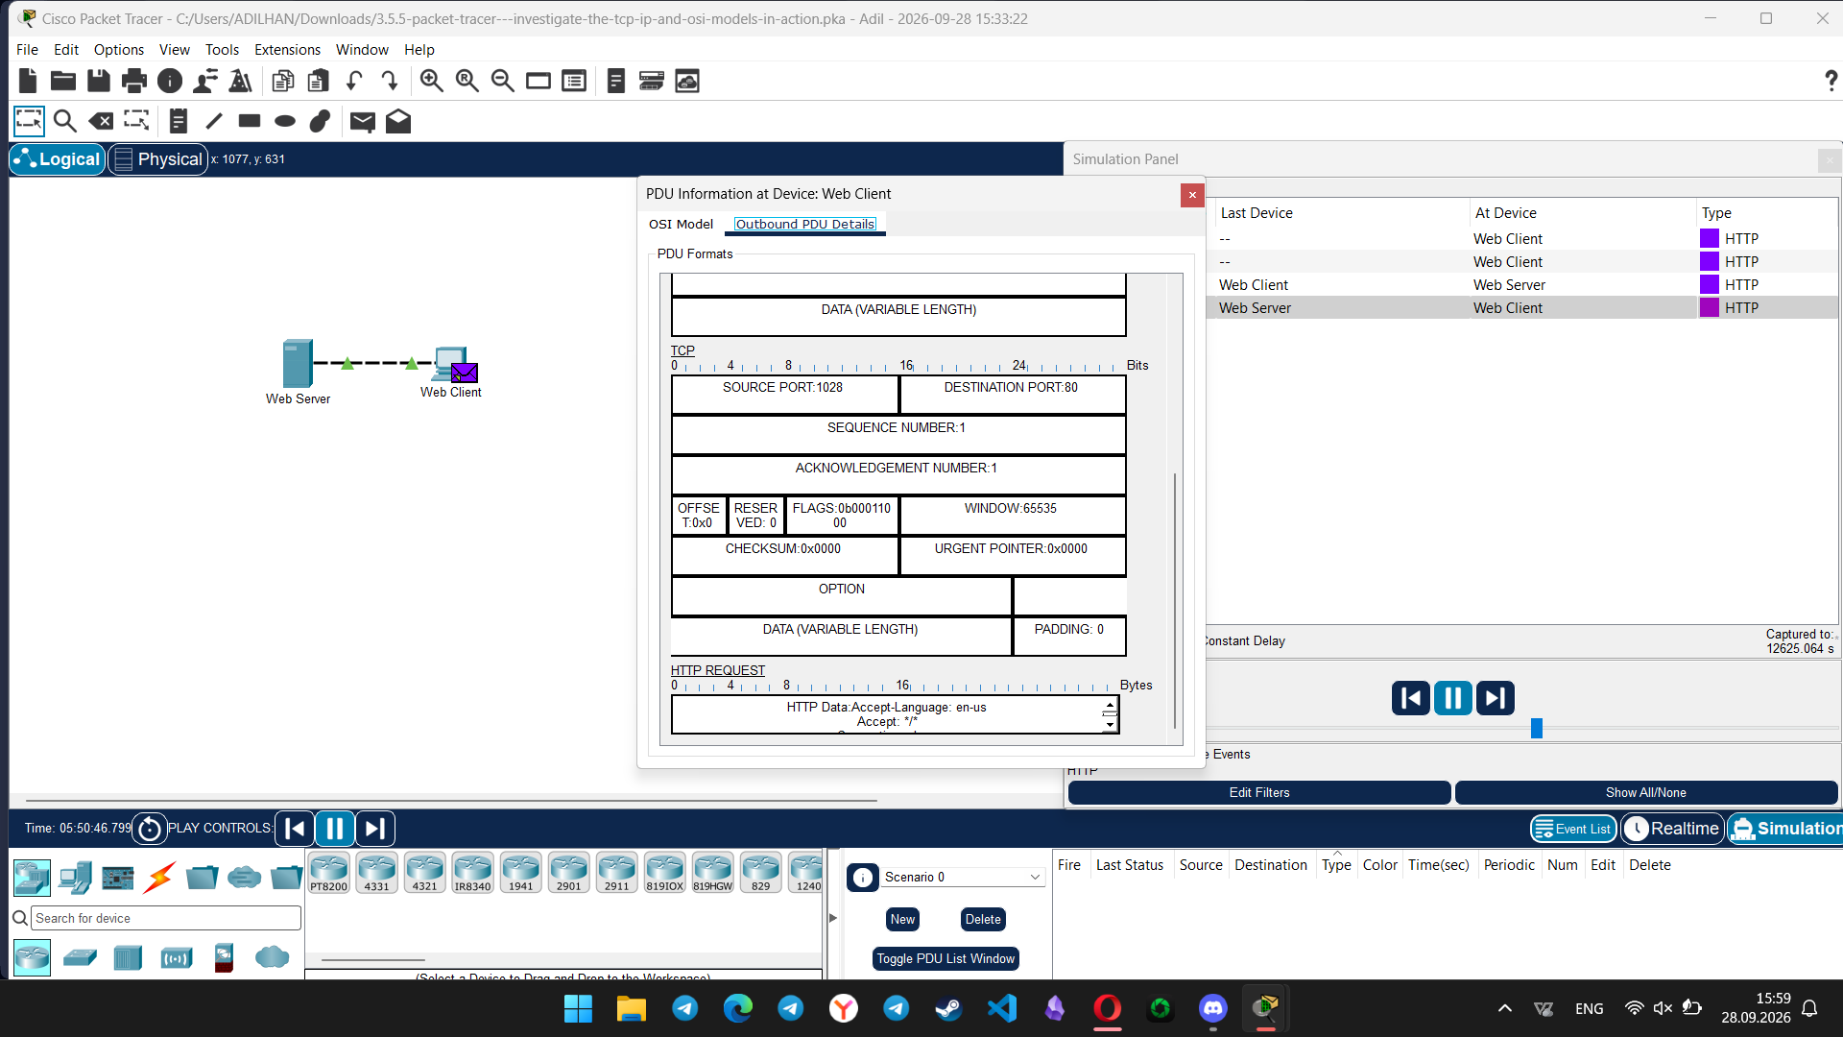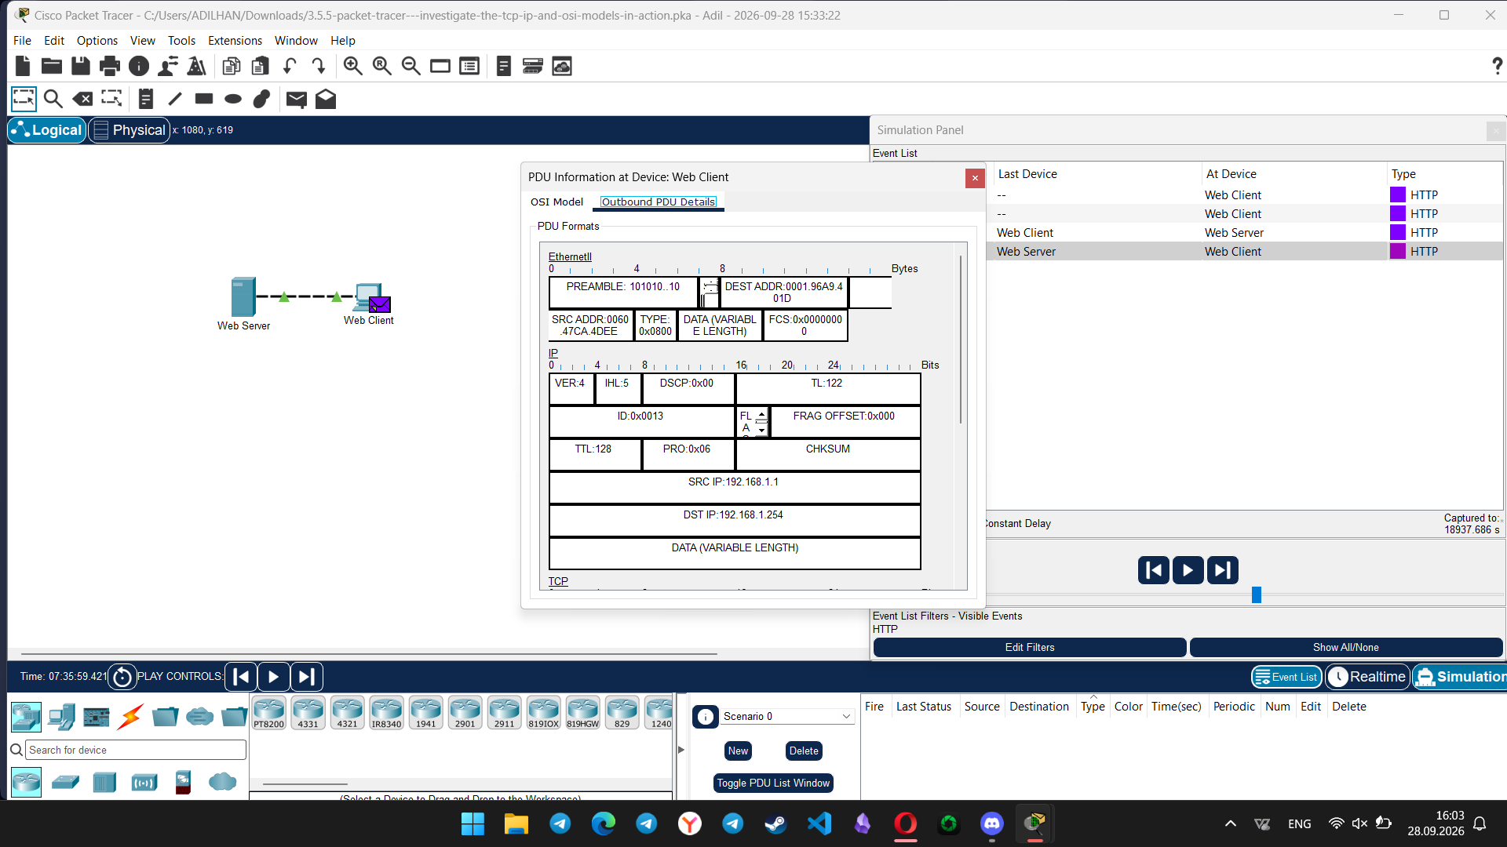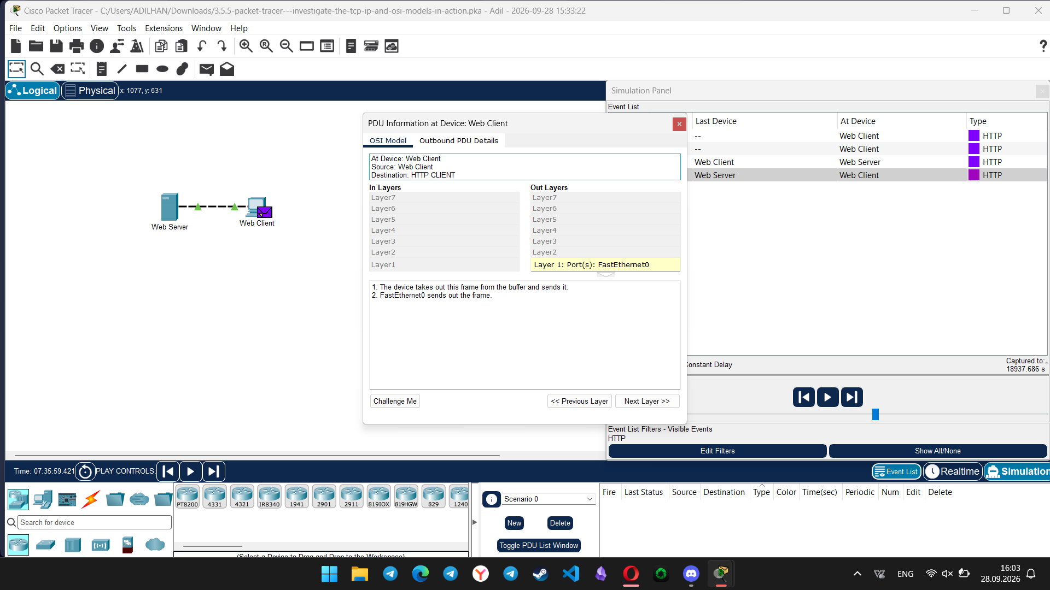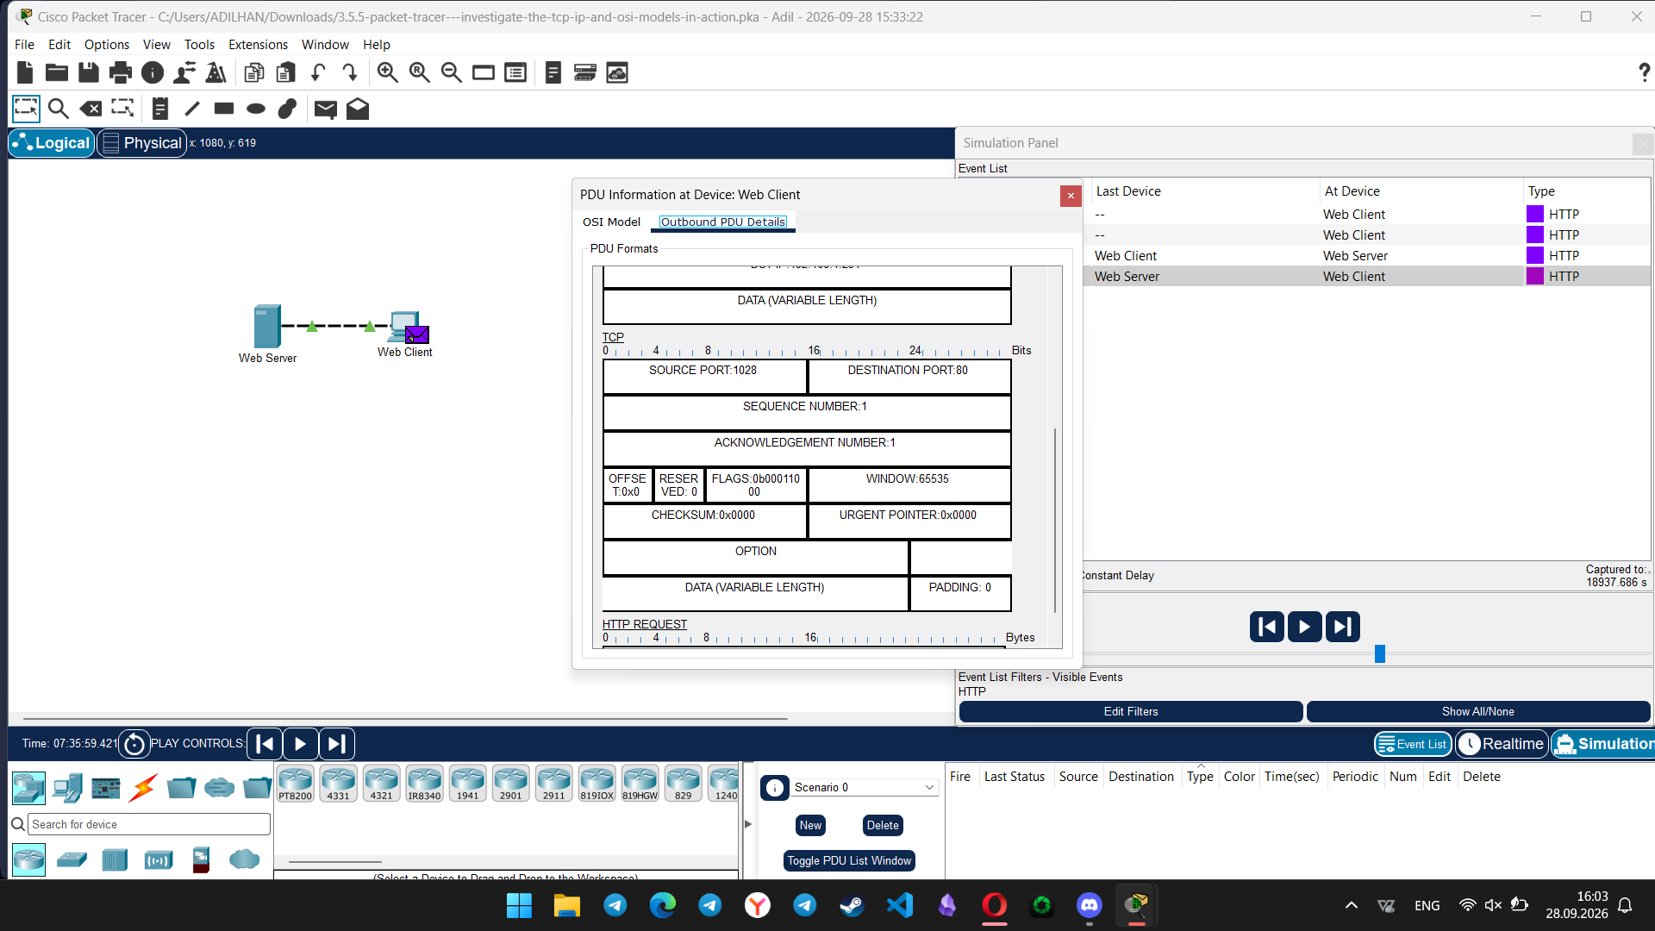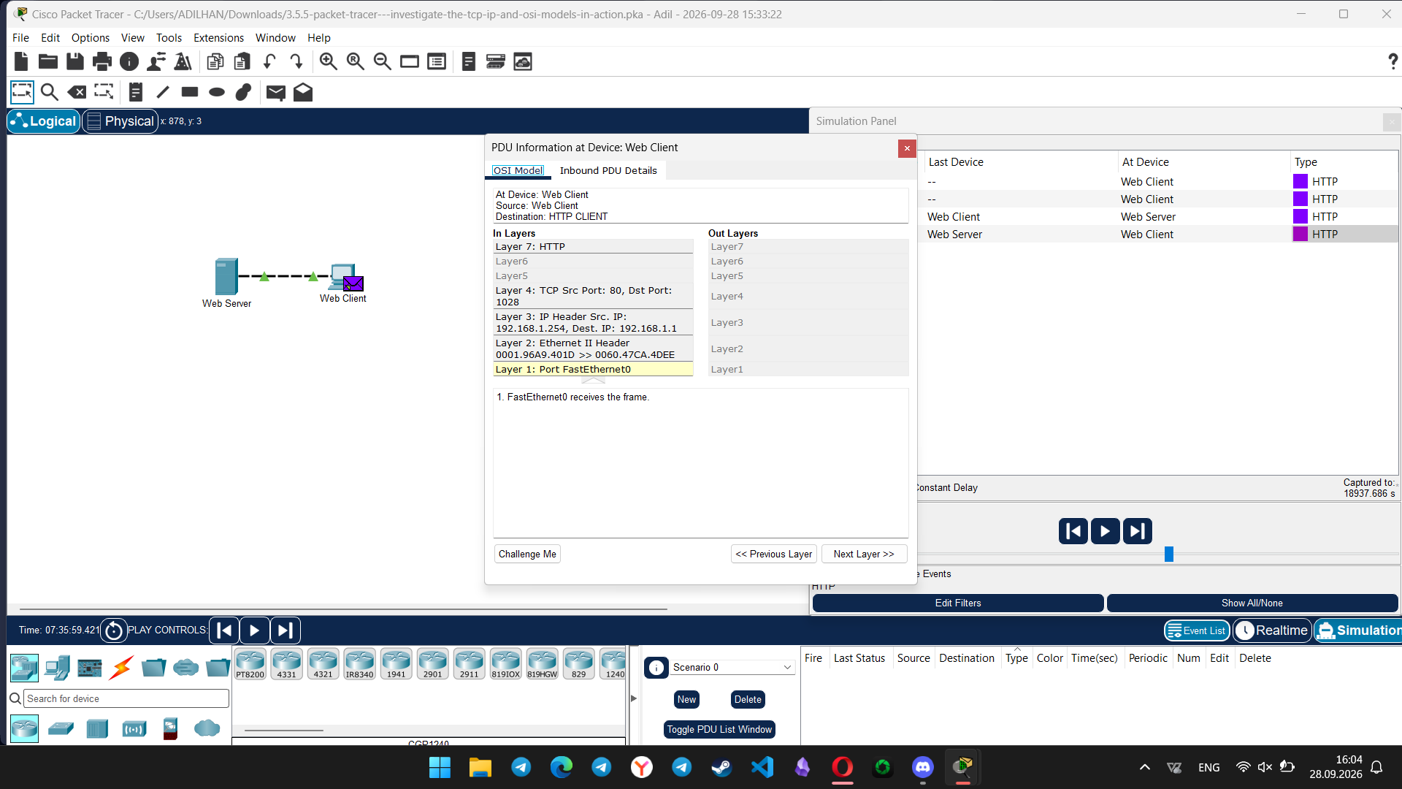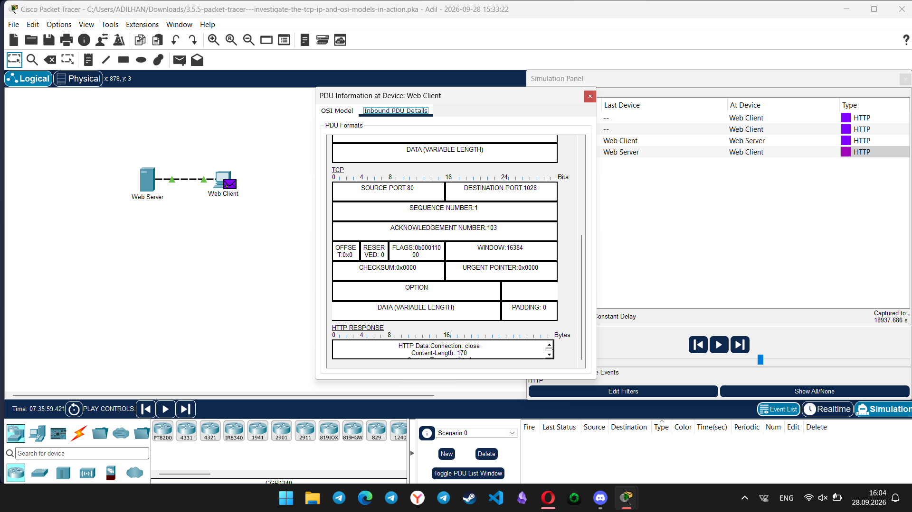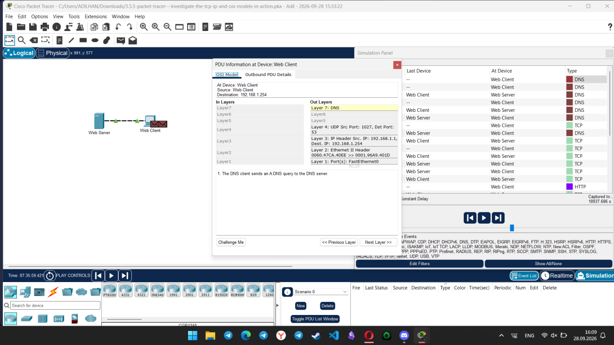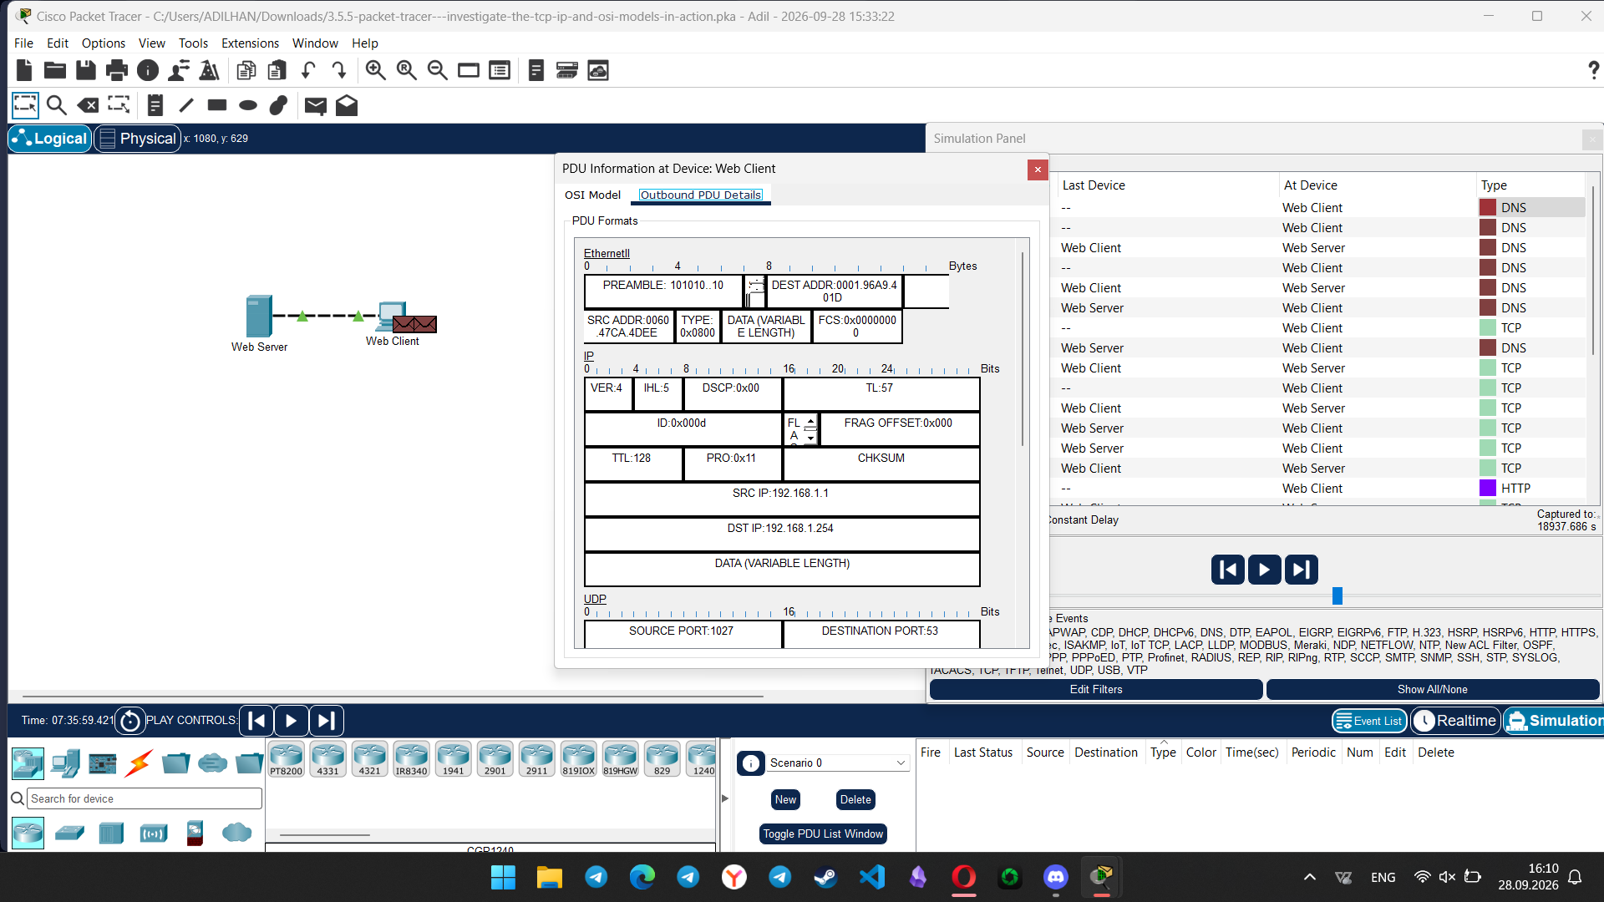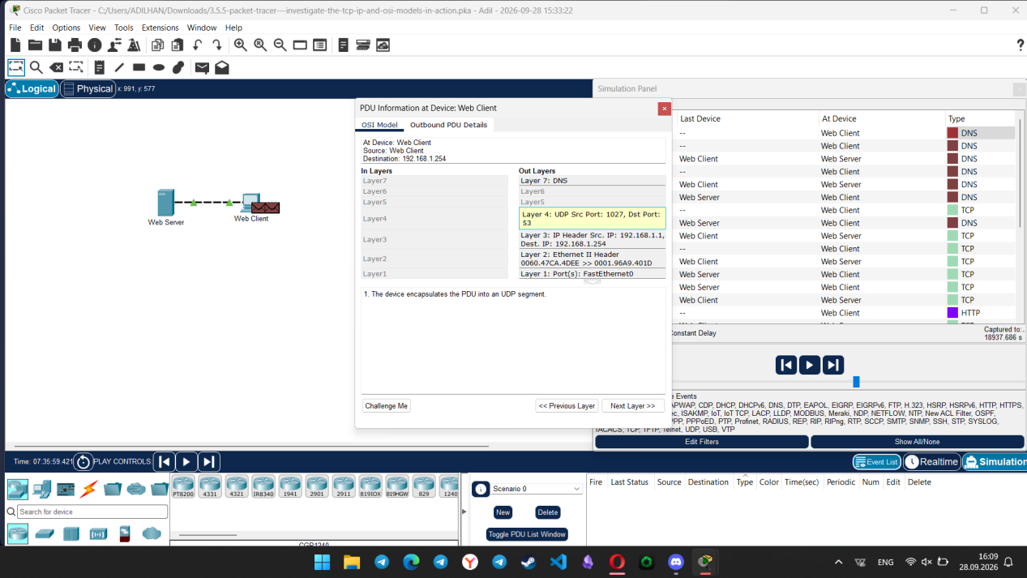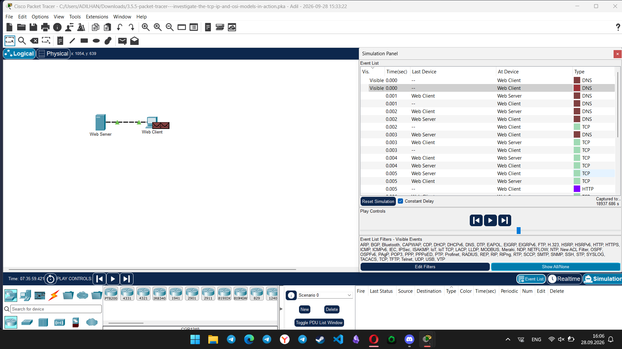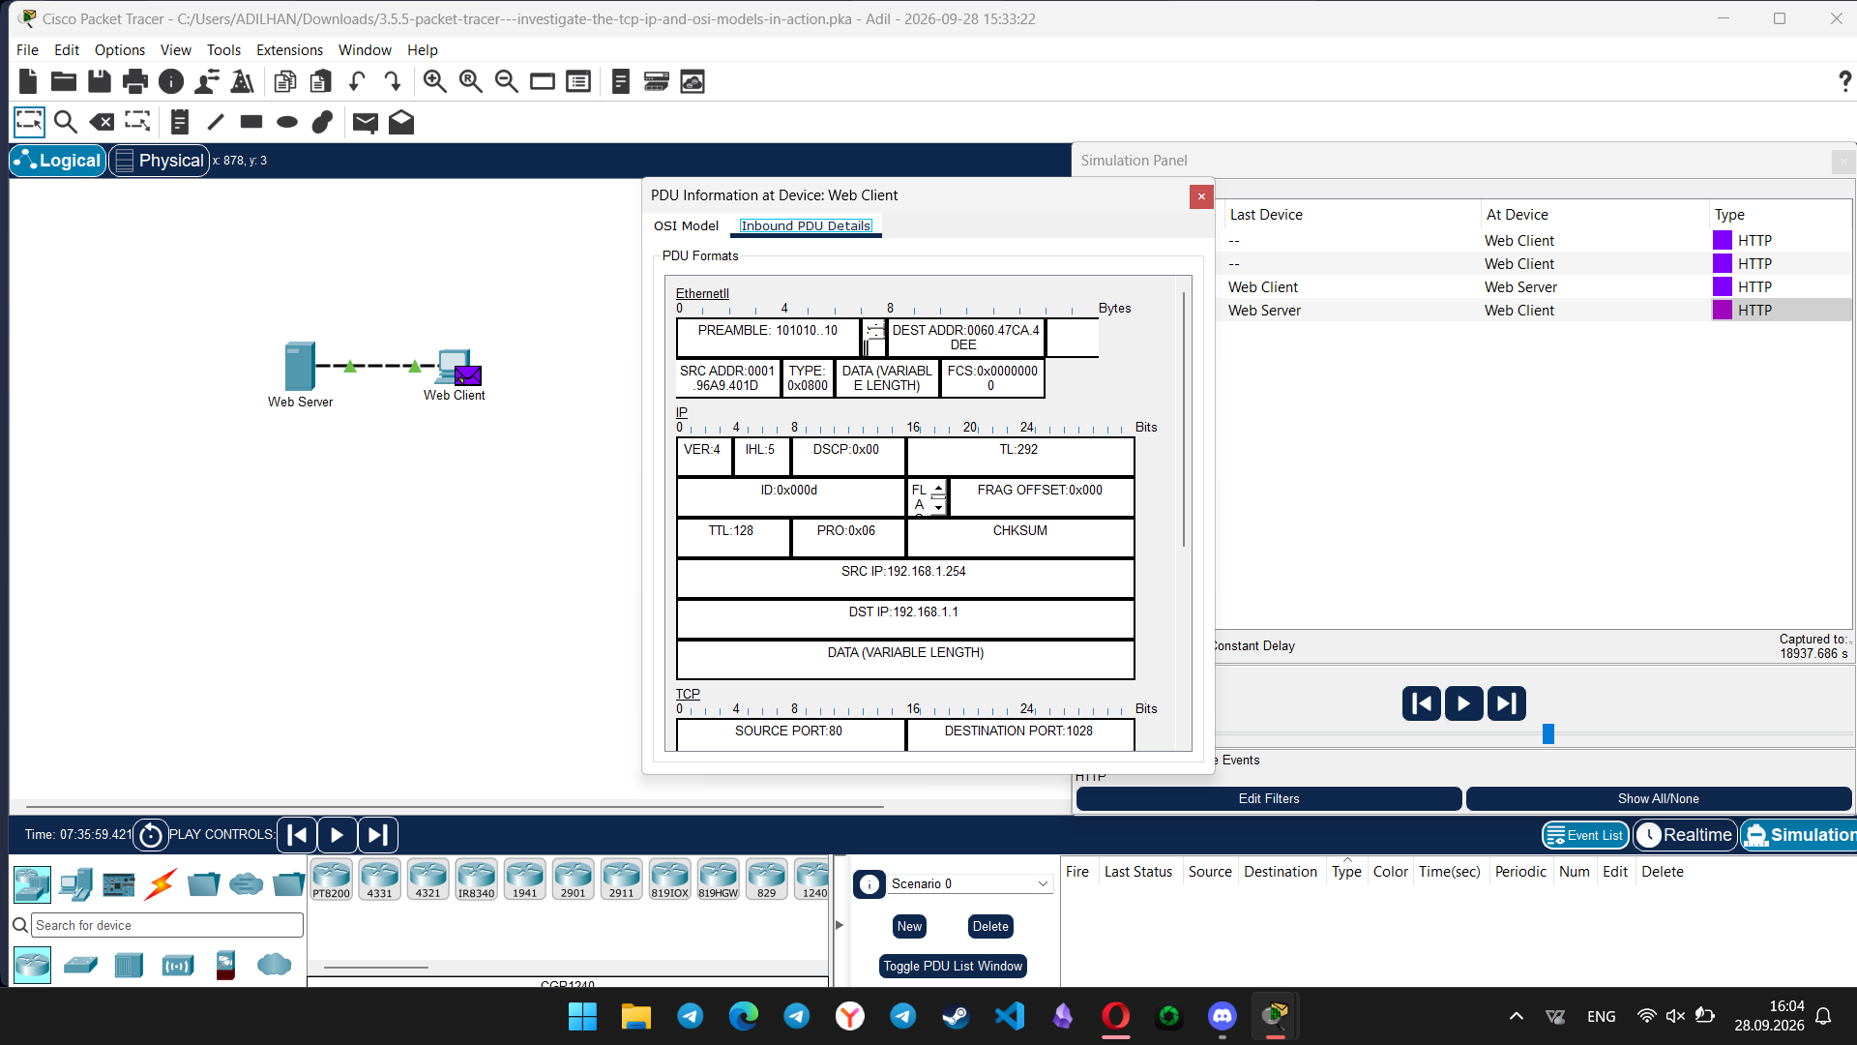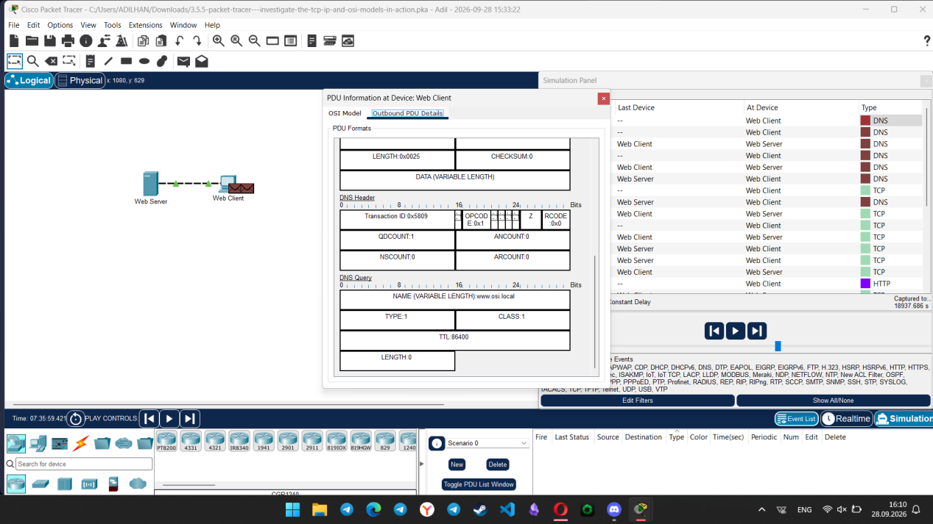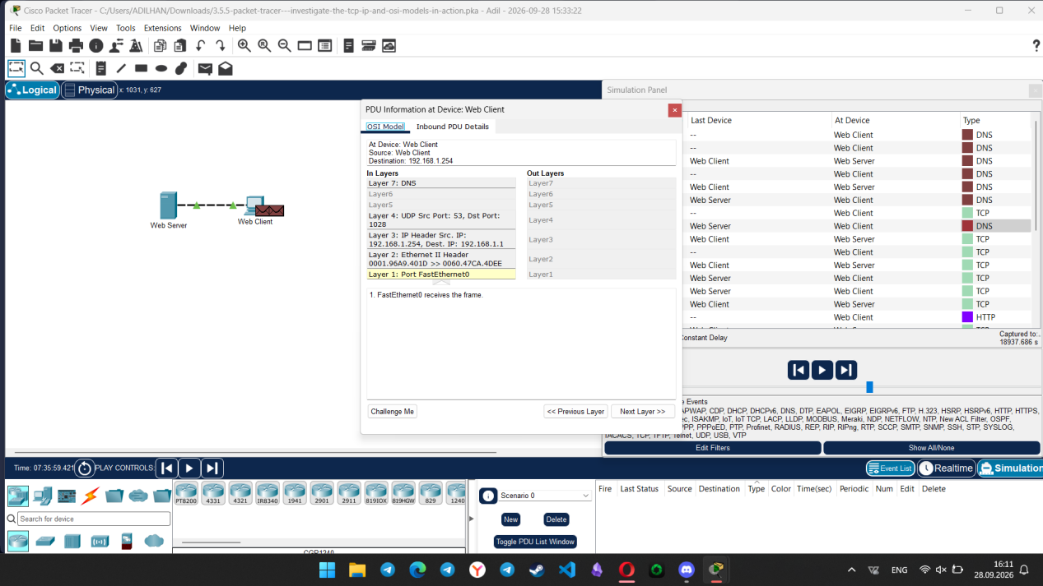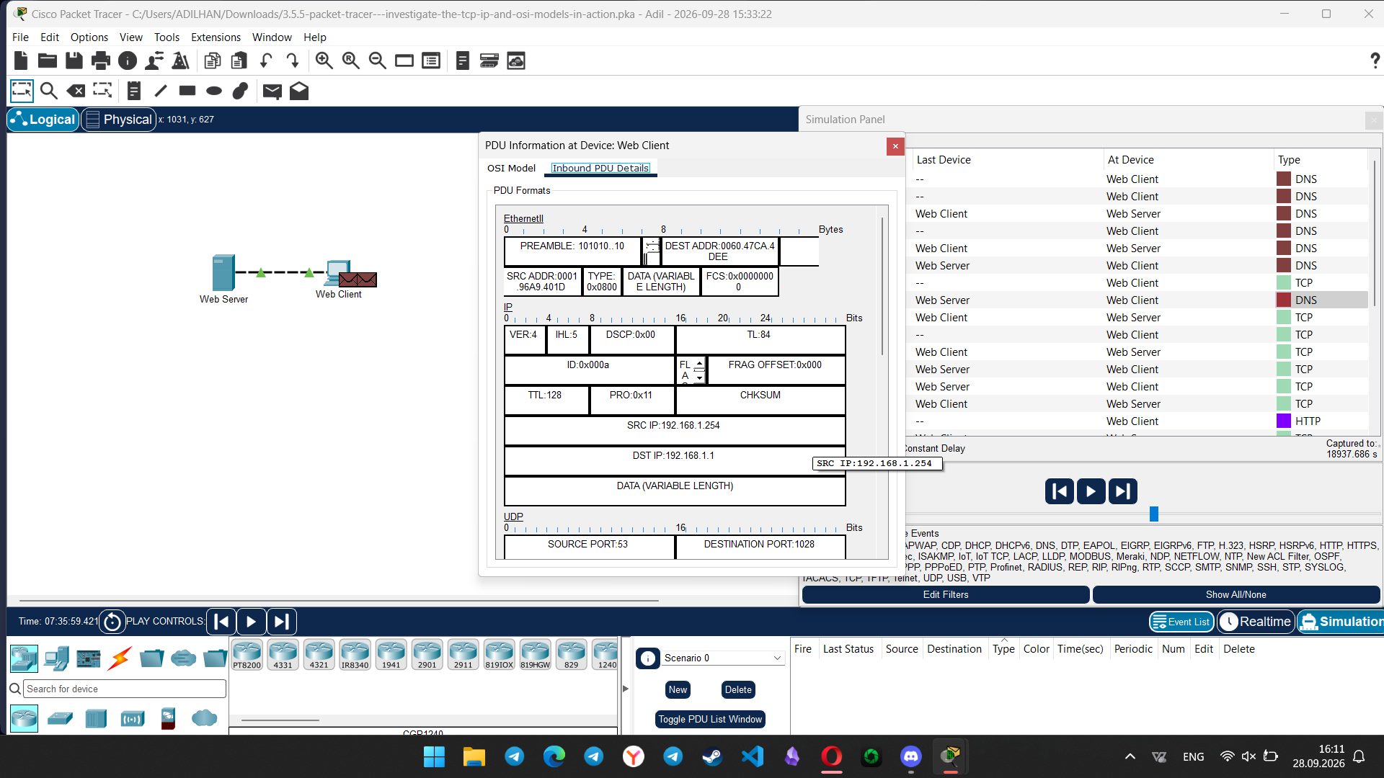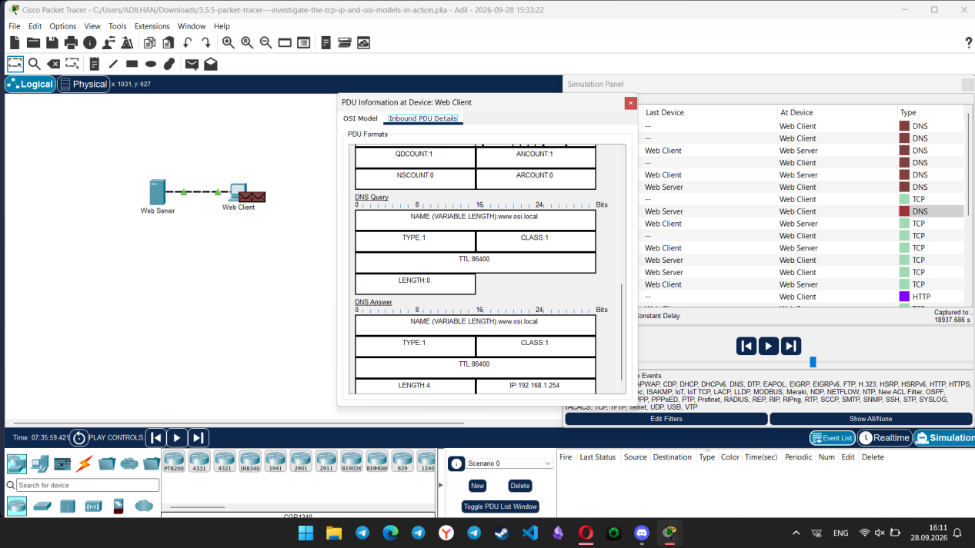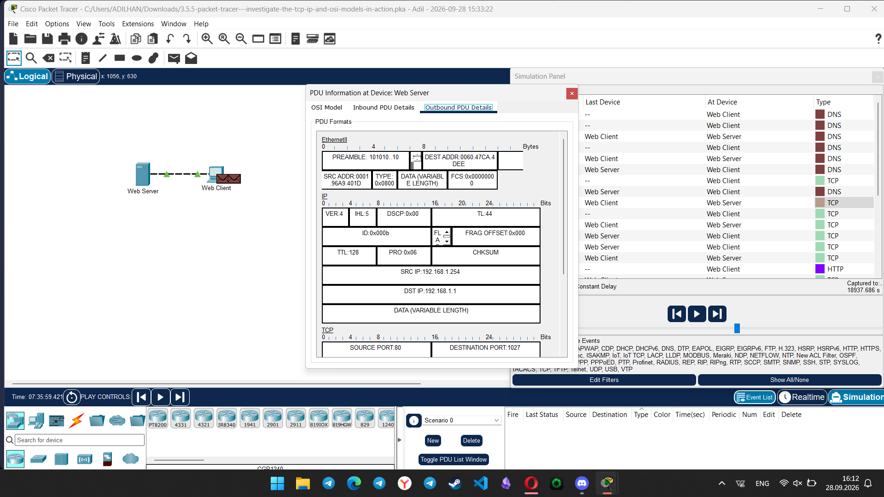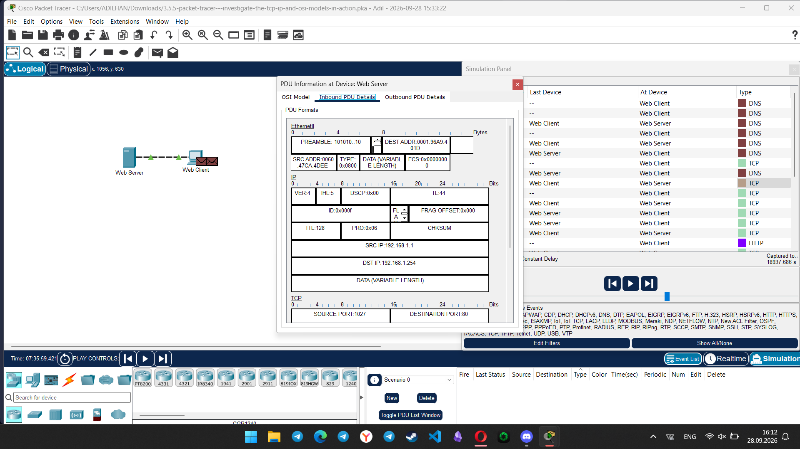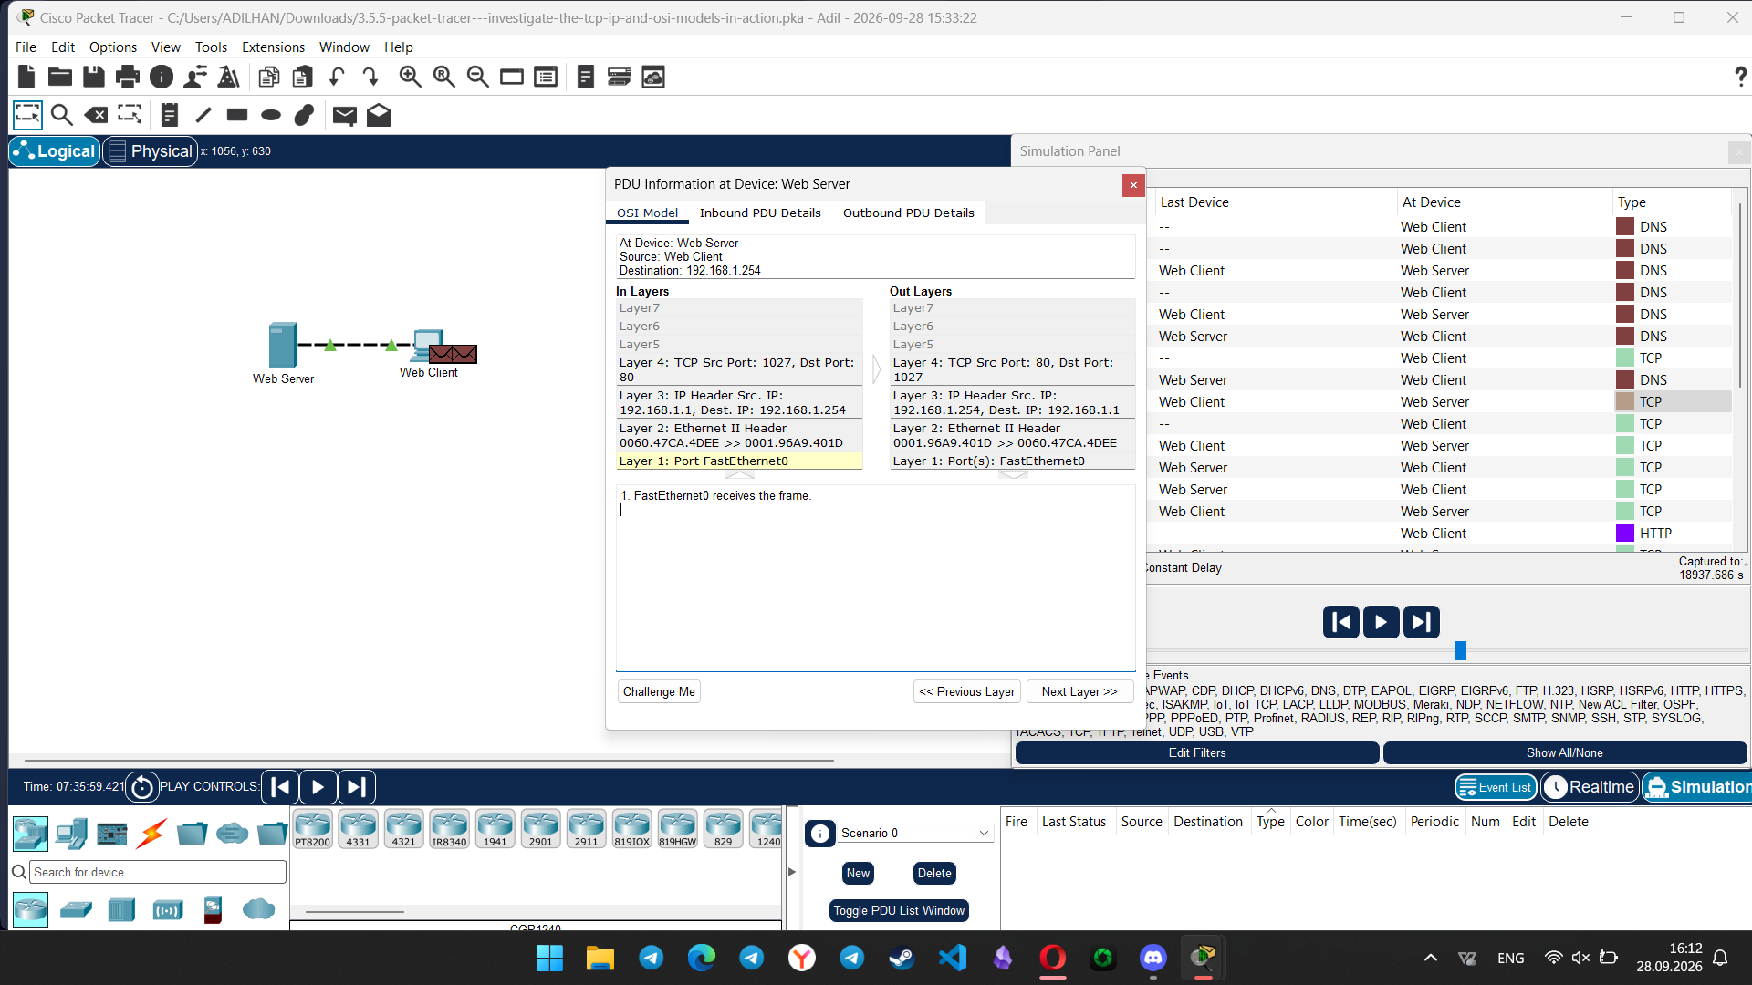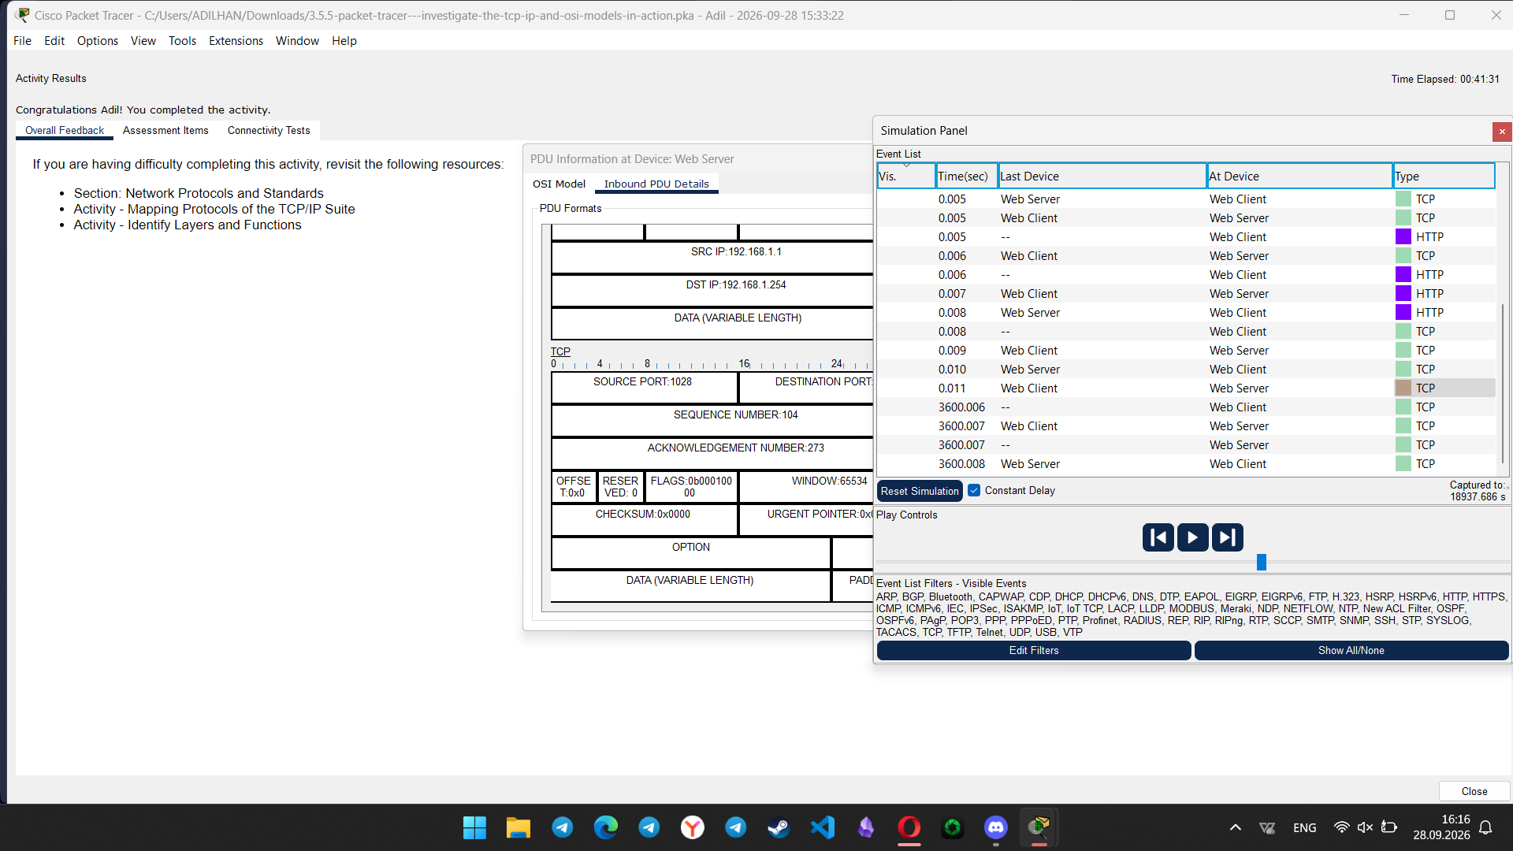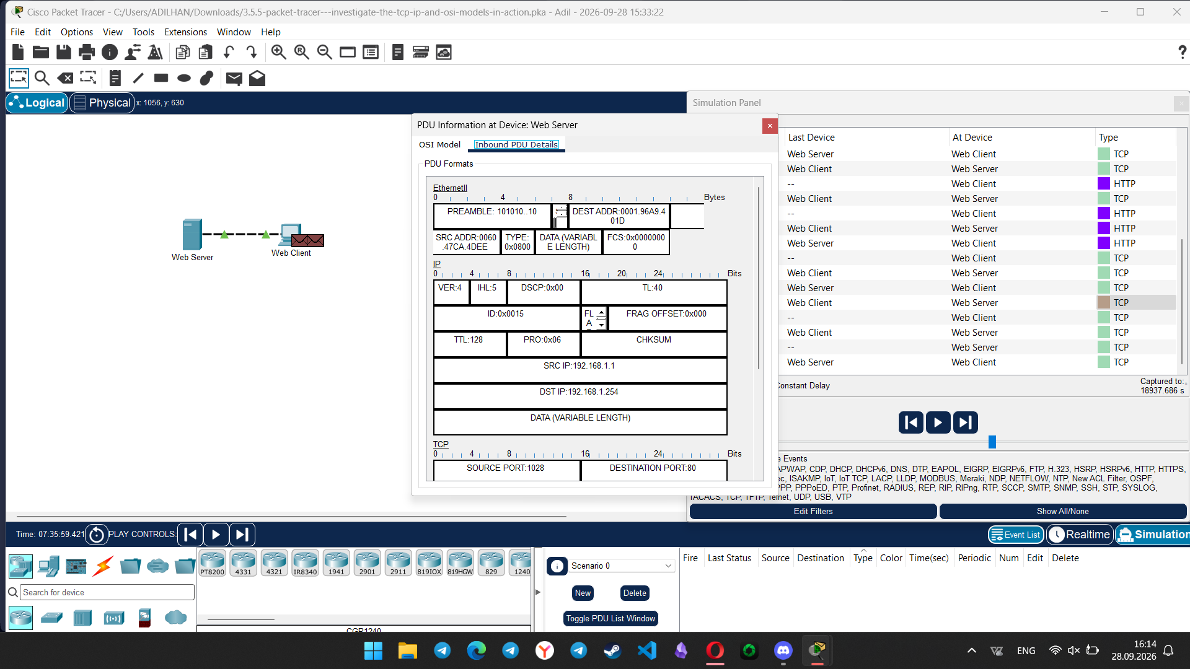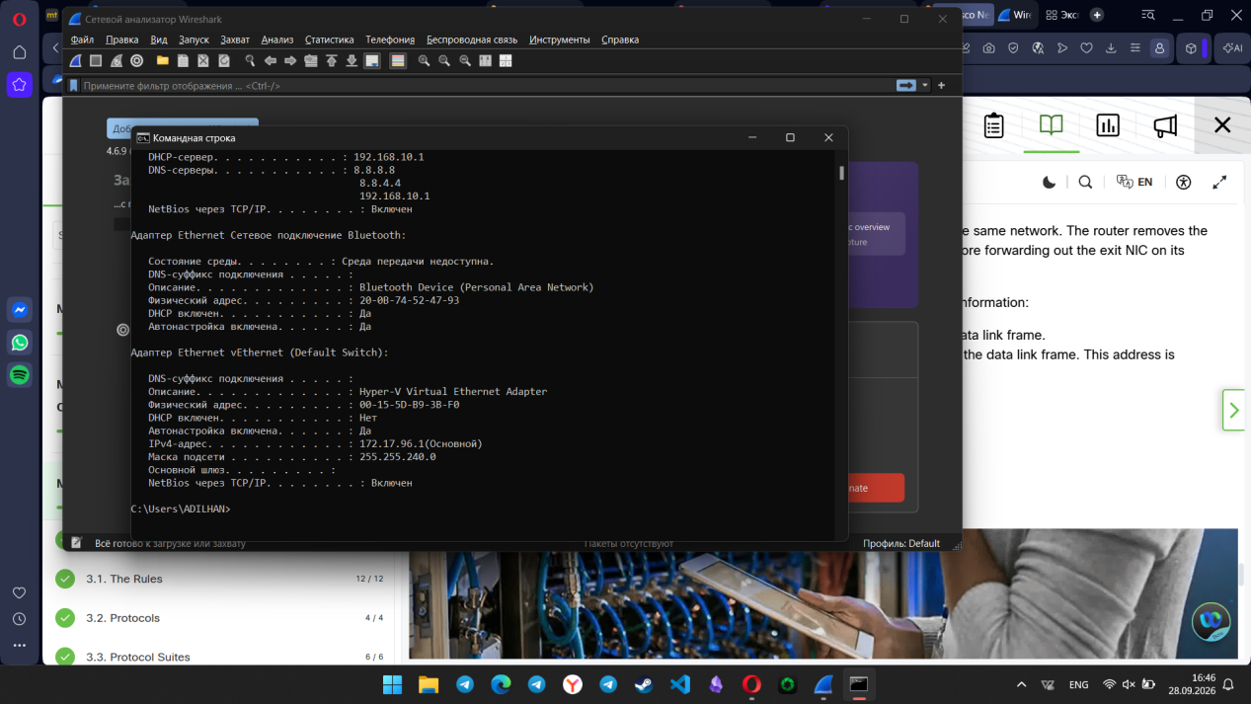
My PC IP address: 192.168.10.3
My PC MAC address: 20:0B:74:52:47:92
Does the source MAC address match your PC interface?
Yes, it matches perfectly.
Does the destination MAC address in Wireshark match your team member MAC address?
Yes. For this lab, the default gateway (router) was used as the local team member. The destination MAC address matches the router's MAC address (54:78:f0:81:3a:f0).
How is the MAC address of the pinged PC obtained by your PC?
The PC obtains the destination MAC address using ARP (Address Resolution Protocol). It sends a broadcast request to the local network to discover the MAC address associated with the target IP address.
Step 2: Examining and analyzing the data from the remote hosts
IP address for www.yahoo.com: 87.248.119.251
MAC address for www.yahoo.com: 54:78:f0:81:3a:f0
MAC address for www.cisco.com: 54:78:f0:81:3a:f0
IP address for www.google.com: 142.251.13.139
MAC address for www.google.com: 54:78:f0:81:3a:f0
What is significant about this information? How does this information differ from the local ping information you received in Part 1?
The significant finding is that while the destination IP addresses for Yahoo, Cisco, and Google are all different, their destination MAC addresses are exactly the same. In a local ping (Part 1), the destination MAC address belongs to the specific target device. In a remote ping, the destination MAC address is always the MAC address of the local default gateway (router)
Why does Wireshark show the actual MAC address of the local hosts, but not the actual MAC address for the remote hosts?
MAC addresses operate at Layer 2 (Data Link) and are only used for frame delivery within the same local area network (LAN). They are not routed across the Internet. When sending packets to remote hosts outside the local network, the PC must send the Ethernet frame to its default gateway first. Therefore, Wireshark captures the router's MAC address as the destination. The routing to the actual remote server over the internet is handled via IP addresses at Layer 3.
